**A. Display EName and Sal of employees whose salary is greater than or equal to 2200:**

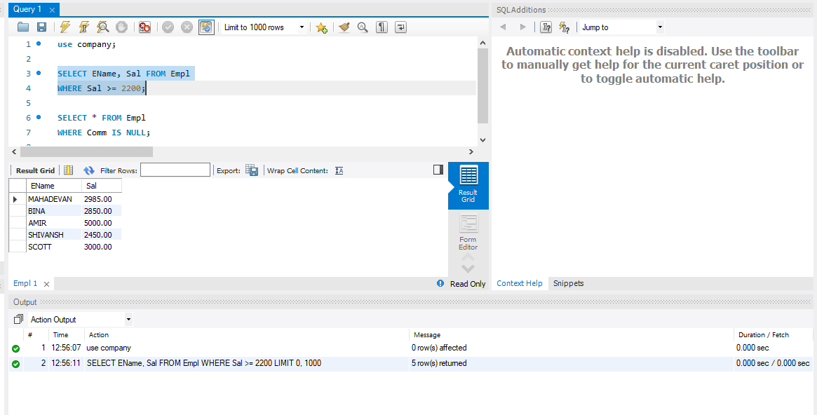

**B. Display details of employees who are not getting commission:**

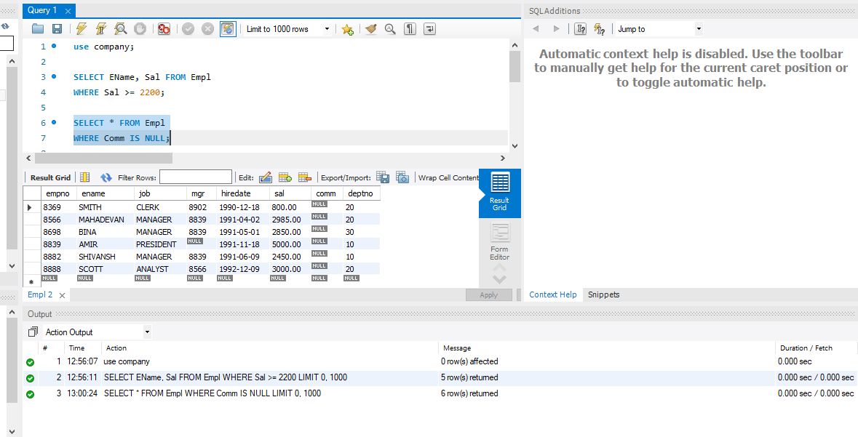

**C. Write a query to display employee name and salary of those employees who don't have their salary in the range of 2500 to 4000?**

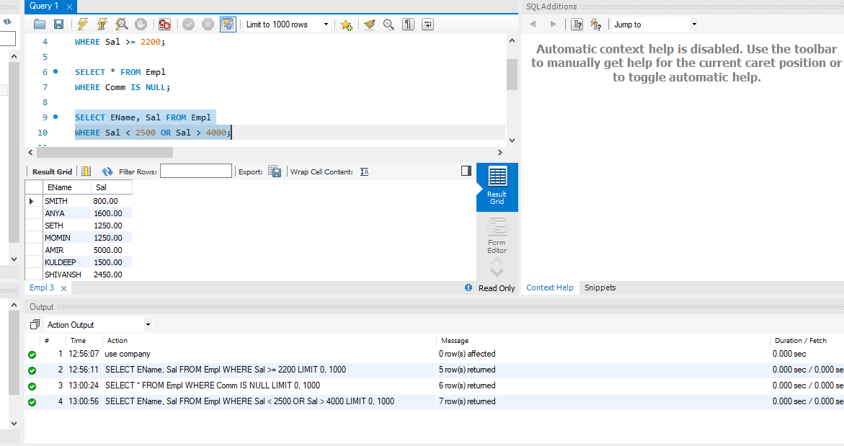

**D. Write a query to display the name, job title and salary of employees who don't have a manager?**

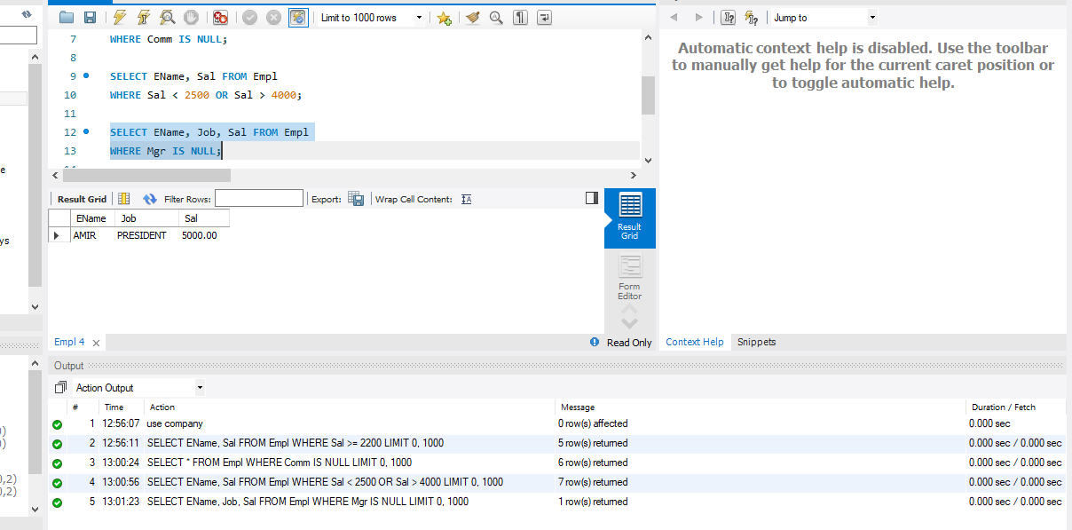

**E. Write a query to display the name of an employee whose name contains "A" as third alphabet?**

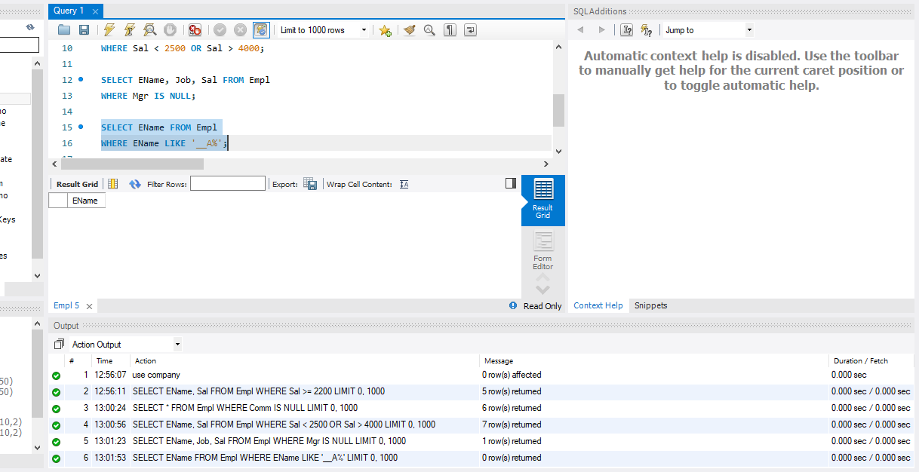

**F. Write a query to display the name of an employee whose name contains "T" as the last alphabet?**

